Prof. Knezevic

ME 643

4/17/19

Deliverable 2

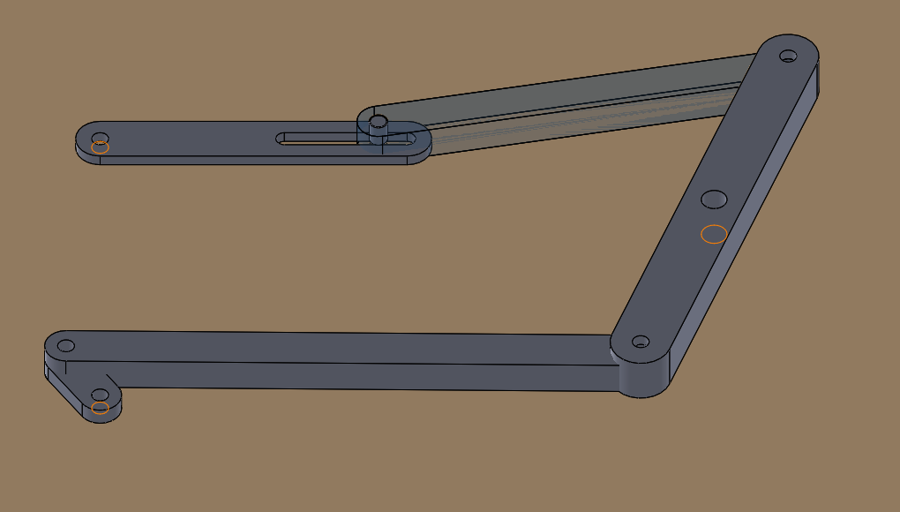

***Authors***

*Joeseph Williams*

*Thomas Collins*

*Lucas Simmonds*

*Ross Thyne*

*Charlie Nitschelm*

Contents

Table of Figures 2

Table of Tables 2

Beam Equations 3

Maximum and Minimum Axial Stress: 3

Maximum and Minimum Bending Stress: 3

Maximum and Minimum Combined Stress: 3

Mean & Alternating Stress: 3

Buckling 3

Deflection 3

Factor of Safety’s 4

Pin Equations 4

Pin Shear Stress 4

Pin Bearing Stress 4

Pin Tear-Out Stress 4

Factor of Safety’s 4

Beam Dimensions 5

Beam Calculations and Values 5

Pin Calculations and Values 6

Solidworks Drawings of Members 6

Appendix 10

MATLAB Code 10

# Table of Figures

Figure 1 - Drawing of Member OA 6

Figure 2 - Drawing of Member AB 7

Figure 3 - Drawing of Member BD 7

Figure 4 - Drawing of Member DE 8

Figure 5 - 2D Figure of Full Assembly 8

Figure 6 - 3D Figure of Full Assembly 9

# Table of Tables

Table 1 - Beam Dimensions 5

Table 2 - Beam Stresses and Factor of Safety's 5

Table 3 - Pin Dimensions, Forces, and Factor of Safety's 6

# Beam Equations

## Maximum and Minimum Axial Stress:

## Maximum and Minimum Bending Stress:

## Maximum and Minimum Combined Stress:

## Mean & Alternating Stress:

## Buckling

## Deflection

## Factor of Safety’s

# Pin Equations

## Pin Shear Stress

## Pin Bearing Stress

## Pin Tear-Out Stress

## Factor of Safety’s

# Beam Dimensions

Table - Beam Dimensions

|  |  |  |  |  |
| --- | --- | --- | --- | --- |
| Link | Length (in) | Base (in) | Height (in) | Schematic Drawing |
| OA | 0.5 | 0.35 | 0.15 | h |
| AB | 4.68 | 0.35 | 0.3 | h  b  b |
| BD | 3.5 | 0.5 | 0.4 | h |
| DE | 3.4 | 0.35 | 0.3 | h  b  b |

# Beam Calculations and Values

Table - Beam Stresses and Factor of Safety's

|  |  |  |  |  |
| --- | --- | --- | --- | --- |
|  | **Member OA** | **Member AB** | **Member BD** | **Member DE** |
| **Maximum Stress (psi)** | 434.3 | 14.2 | 76.9 | 14.3 |
| **Minimum Stress (psi)** | 418.9 | 5.0 | 20.6 | 5.1 |
| **Mean Stress (psi)** | 426.6 | 9.6 | 48.7 | 9.7 |
| **Alternating Stress (psi)** | 7.7 | 4.6 | 28.2 | 4.6 |
| **Tearout Stress (psi)** | 6.6 | 12.3 | 1.6 | 12.4 |
|  | 6.5 | 98.7 | 17.0 | 98.4 |
|  | 85.6 | 144.4 | 23.4 | 144.4 |
|  | 6.0 | 495.3 | 121.7 | 486.1 |
|  | 5.8 | 176.2 | 32.5 | 175.0 |
|  | 117.3 | 5.7 | 274.5 | 10.8 |
|  | 3.5 | Infinite | 2.8 | Infinite |
|  | 270.6 | 145.3 | 1283.0 | 144.3 |
| **Failure Mode** | **Deflection** | **Buckling** | **Deflection** | **Buckling** |

# Pin Calculations and Values

Table - Pin Dimensions, Forces, and Factor of Safety's

|  |  |  |  |  |  |
| --- | --- | --- | --- | --- | --- |
| **Pin** | **A** | **B** | **C** | **D** | **E** |
| **Diameter (in)** | 0.1 | 0.1 | 0.2 | 0.1 | 0.1 |
| **Length (in)** | 0.2 | 0.2 | 0.2 | 0.2 | 0.2 |
| **Max Force (lb)** | 1.5 | 1.5 | 3.0 | 1.5 | 1.5 |
| **Shear Stress (psi)** | 10.8 | 10.8 | 9.3 | 10.9 | 10.9 |
| **Bending Stress (psi)** | 69.9 | 69.9 | 91.5 | 70.4 | 70.4 |
|  | 231.1 | 231.1 | 269.3 | 229.6 | 229.6 |
|  | 35.7 | 35.7 | 27.3 | 35.5 | 35.5 |
| **Failure Mode** | **Bearing** | **Bearing** | **Bearing** | **Bearing** | **Bearing** |

# Solidworks Drawings of Members

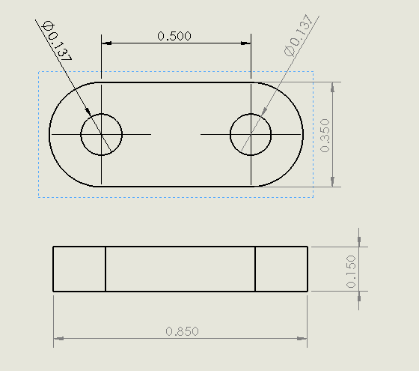

Figure - Drawing of Member OA

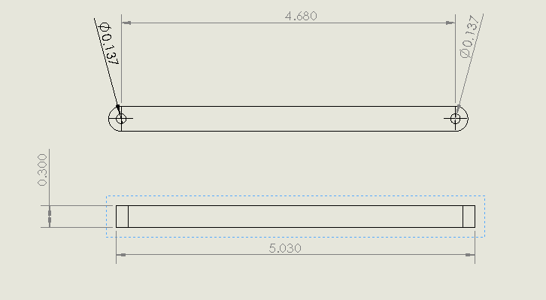

Figure - Drawing of Member AB

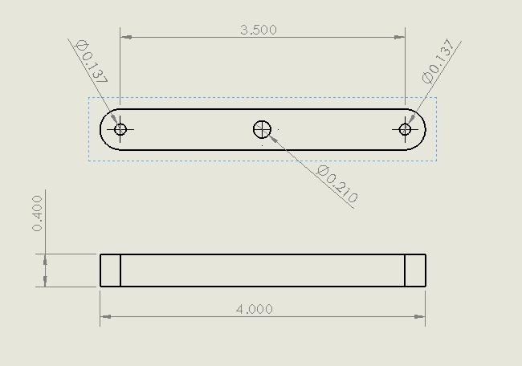

Figure - Drawing of Member BD

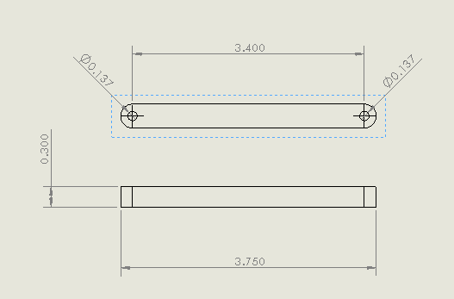

Figure - Drawing of Member DE

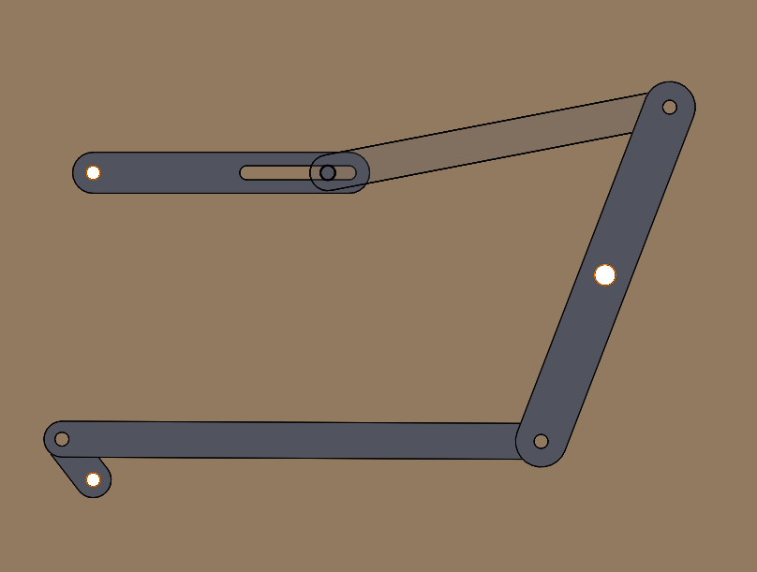

Figure - 2D Figure of Full Assembly



Figure - 3D Figure of Full Assembly

# Appendix

## MATLAB Code

clear all; close all; clc

%Plastic Properties Given

Mod_El=230000; %Modulus of Elasticity E = 230000psi

Sig_y=2500; %Yeild Strength Sig_y = 2500psi

Sig_uts=3000; %Ultamate Tensile Strength Sig_uts = 3000psi

Density=0.0376; %Density = 0.0376lb/in^3

%Extra Definitions

w=50; %Omega = 50rpm

theta=(0:1:360).*(pi/180); %Singular Rotation

k=1; %lbf/in

%Lengths Determined

r_AB = 4.68;

r_BD = 3.5;

r_DE = 3.4;

%Lengths Defined

r_OA = 0.5;

r_EF = 2.5;

%Geometry of Each Segment

%Base = b

%Height = h

%Base

dimb = .35;

dimh = .30;

b_AB=dimb;

b_DE=dimb;

b_EF=dimb;

%Height

h_AB=dimh;

h_EF=dimh;

h_DE=dimh;

% member BD 3

dim2b = .5;

dim2h = .4;

h_BD=dim2h;

b_BD=dim2b;

%Member OA

dim3b = .35;

dim3h = .15;

b_OA=dim3b;

h_OA=dim3h;

%Dimentions [In Inches]

Width=dimh/2;

Width2=dim2h/2;

Width3=dim3h/2;

Thickness=0.125;

Area=[b_OA*h_OA,b_AB*h_AB,b_BD*h_BD,b_EF*h_EF];

%Y values for Bending Calculations

y_OA=h_OA/2;

y_AB=h_AB/2;

y_BD=h_BD/2;

y_DE=h_DE/2;

%Inertia Calculations

I_OA=(b_OA*(h_OA^3))/12;

I_AB=(b_AB*(h_AB^3))/12;

I_BD=(b_BD*(h_BD^3))/12;

I_DE=(b_DE*(h_DE^3))/12;

%Inertia Matrix

I=[I_OA,I_AB,I_BD,I_DE];

%Moment Table from Deliverable 1 Solution

%Values in lb*in

Mmax_OA=0.56;

Mmin_AB=0.00;

Mmax_BD=2.67;

Mmin_DE=0.00;

Mmin_OA=0.54;

Mmax_AB=0.00;

Mmin_BD=0.72;

Mmax_DE=0.00;

Mmin_Bending=[Mmin_OA,Mmin_AB,Mmin_BD,Mmin_DE];

Mmax_Bending=[Mmax_OA,Mmax_AB,Mmax_BD,Mmax_DE];

Min_Bending_Stress=zeros(1,4);

Max_Bending_Stress=zeros(1,4);

for i=1:4

if i == 3

Min_Bending_Stress(i)=(Mmin_Bending(i)*(Width2/2)/I(i));

Max_Bending_Stress(i)=(Mmax_Bending(i)*(Width2/2)/I(i));

end

Min_Bending_Stress(i)=(Mmin_Bending(i)*(Width/2)/I(i));

Max_Bending_Stress(i)=(Mmax_Bending(i)*(Width/2)/I(i));

end

%Axial Forces Table from Deliverable 1 Solution

%Values in lb

Ax_Mmax_OA=0.4;

Ax_Mmax_AB=1.49;

Ax_Mmin_BD=0.06;

Ax_Mmax_DE=1.50;

Ax_Mmin_OA=0.39;

Ax_Mmin_AB=0.53;

Ax_Mmax_BD=0.36;

Ax_Mmin_DE=0.54;

% %Maxiumum Compression Table from Deliverable 1 Solution

% %Values in lb

% CMax_OA=-1.49;

% CMax_AB=-1.49;

% CMax_BD=-0.46; %Located in BC Region

% CMax_DE=-1.5;

%Maxiumum Force in each Pin Table from Deliverable 1 Solutions

%Values in lb

FMax_A=1.49;

FMax_B=1.49;

FMax_C=2.97;

FMax_D=1.5;

FMax_E=1.5;

F = [FMax_A,FMax_B,FMax_C,FMax_D,FMax_E]

%Bending Calculations

%Bending values calulated by (M*y)/I

%Maximum

Bending_Max_OA=(Mmax_OA*y_OA)/I_OA;

Bending_Max_AB=(Mmax_AB*y_AB)/I_AB;

Bending_Max_BD=(Mmax_BD*y_BD)/I_BD;

Bending_Max_DE=(Mmax_DE*y_DE)/I_DE;

%Minimum

Bending_Min_OA=(Mmin_OA*y_OA)/I_OA;

Bending_Min_AB=(Mmin_AB*y_AB)/I_AB;

Bending_Min_BD=(Mmin_BD*y_BD)/I_BD;

Bending_Min_DE=(Mmin_DE*y_DE)/I_DE;

%Bending Stress Matrix

%Max_Bending_Stress=[Bending_Max_OA,Bending_Max_AB,Bending_Max_BD,Bending_Max_DE];

%Min_Bending_Stress=[Bending_Min_OA,Bending_Min_AB,Bending_Min_BD,Bending_Min_DE];

%Axial Calculations

%Axial Stress Matrix

Max_Axial=[Ax_Mmax_OA,Ax_Mmax_AB,Ax_Mmax_BD,Ax_Mmax_DE];

Min_Axial=[Ax_Mmin_OA,Ax_Mmin_AB,Ax_Mmin_BD,Ax_Mmin_DE];

Max_Axial_Stress=Max_Axial./Area;

Min_Axial_Stress=Min_Axial./Area;

%Combined Stress Calculations

Max_Comb_Stress=zeros(1,4);

Min_Comb_Stress=zeros(1,4);

for i=1:4

Max_Comb_Stress(i)=Max_Bending_Stress(i)+Max_Axial_Stress(i);

Min_Comb_Stress(i)=Min_Bending_Stress(i)+Min_Axial_Stress(i);

end

%Mean and Alternating Stress

Mean_Stress=(Max_Comb_Stress+Min_Comb_Stress)./2;

Alt_Stress=(Max_Comb_Stress-Min_Comb_Stress)./2;

%Buckling & Deflection

L=[r_OA,r_AB,r_BD,r_DE];

Buckling = (pi^2*Mod_El*I)./(L.^2);

Max_Deflection=L./360;

Actual_Deflection=(Mmax_Bending.*(L.^2))./(9*sqrt(3)*Mod_El.*I);

%Fatigue

Sf_prime=Sig_uts/2;

Cload=1;

Csize=1;

a_surf=4.511;

b_surf=-0.265;

Csurf=a_surf*Sig_uts^b_surf;

Creliab=0.814;

Ctemp=1;

Sf=Cload*Csize*Csurf*Ctemp*Creliab*Sf_prime;

%Factor of Safety Calculations

%Fatigue

FOS_Fatigue_N1=(Sf*Sig_uts)./((Alt_Stress.*Sig_uts)+(Mean_Stress.*Sf));

%Yeild

FOS_Yeild_Tension=Sig_y./abs(Alt_Stress - Mean_Stress);

FOS_Yeild_N_2=Sf./Alt_Stress;

FOS_Yeild_N_4=Sig_y./(Alt_Stress + Mean_Stress);

%Deflection

FOS_Deflection=Max_Deflection./Actual_Deflection;

%Buckling

FOS_Buckling=Buckling./Max_Axial_Stress;

%Shear Calculations

%Pin Values and Calculations

%Diameter = d [Values in Inches]

d_A=0.137795;

d_B=0.137795;

d_C=0.21;

d_D=0.137795;

d_E=0.137795;

Length=0.19685;

d = [d_A,d_B,d_C,d_D,d_E]

%Shear Stress Calculations per Pin

Shear_Stress_A=sqrt(3)*FMax_A/(pi*d_A^2)/4;

Shear_Stress_B=sqrt(3)*FMax_B/(pi*d_B^2)/4;

Shear_Stress_C=sqrt(3)*FMax_C/(pi*d_C^2)/4;

Shear_Stress_D=sqrt(3)*FMax_D/(pi*d_D^2)/4;

Shear_Stress_E=sqrt(3)*FMax_E/(pi*d_E^2)/4;

%Shear Stress Array

Shear_Stress=[Shear_Stress_A,Shear_Stress_B,Shear_Stress_C,Shear_Stress_D,Shear_Stress_E];

%Bearing Stress Calculations per Pin

Bearing_Stress_A=FMax_A/((pi*d_A*Length)/4);

Bearing_Stress_B=FMax_B/((pi*d_B*Length)/4);

Bearing_Stress_C=FMax_C/((pi*d_C*Length)/4);

Bearing_Stress_D=FMax_D/((pi*d_D*Length)/4);

Bearing_Stress_E=FMax_E/((pi*d_E*Length)/4);

%Bearing Stress Array

Bearing_Stress=[Bearing_Stress_A,Bearing_Stress_B,Bearing_Stress_C,Bearing_Stress_D,Bearing_Stress_E];

%Factor of Safety Pin Calculations

FOS_Shear=Sig_y./Shear_Stress;

FOS_Bearing=Sig_y./Bearing_Stress;

%Tearout Calculations

Tearout_Stress_OA=sqrt(3)*Max_Axial(1)/(2*b_OA*h_OA);

Tearout_Stress_AB=sqrt(3)*Max_Axial(2)/(2*b_AB*h_AB);

Tearout_Stress_BD=sqrt(3)*Max_Axial(3)/(2*b_BD*h_BD);

Tearout_Stress_DE=sqrt(3)*Max_Axial(4)/(2*b_DE*h_DE);

%Tearout Array

Tearout_Stress=[Tearout_Stress_OA,Tearout_Stress_AB,Tearout_Stress_BD,Tearout_Stress_DE];

%Factor of Safety for Tearout

FOS_Tearout=Sig_y./Tearout_Stress;

% Creating FOS Table

t = table(FOS_Fatigue_N1',FOS_Yeild_Tension',FOS_Yeild_N_2'...

,FOS_Yeild_N_4',FOS_Deflection',FOS_Buckling',FOS_Tearout');

t2 = table(FOS_Bearing',FOS_Shear');